1. Find lowest trip during the day. We can see that 10 am has lowest trip between 7 AM – 7 PM.

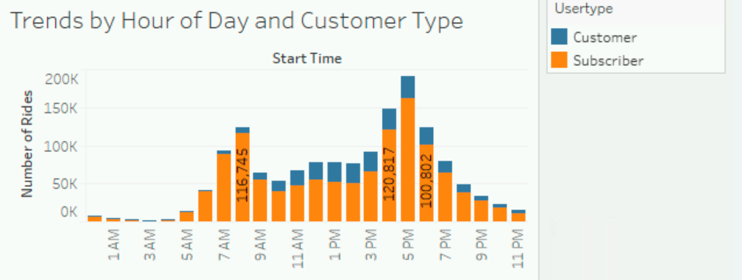

1. Further analysis by customers to see % of riders

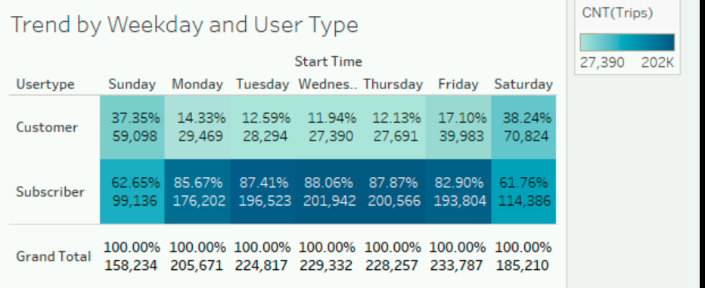

1. Weekday trend by gender and time block using tree map. We see most of riders are men and that the afternoon and morning are busiest time slots.

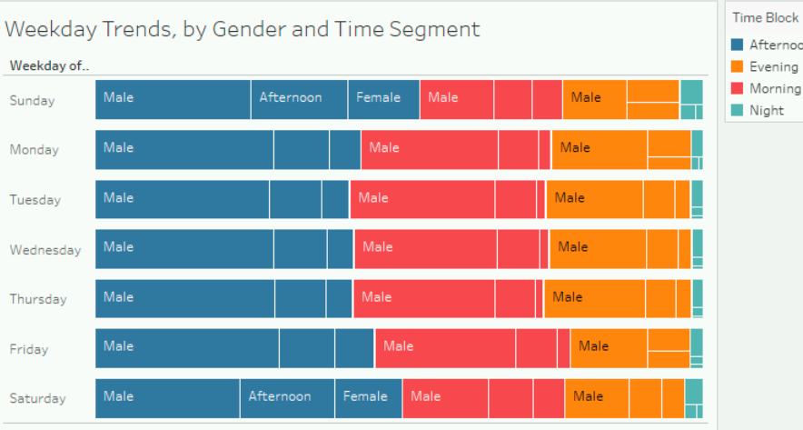

1. The number of riders taken by either male or female on specific date and hour

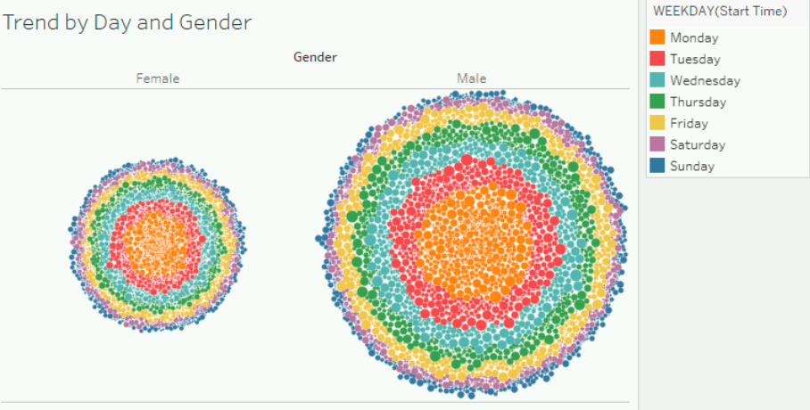

1. Knowing who customers are leading to insights on how the service meets customer needs which can provide operational insights for balancing product availability, as well as showing seasonal variances. In the below, we see that male subscribers have used divvy bike heavily for total 906,649 trips. This info come in handy when setting up a marketing campaign.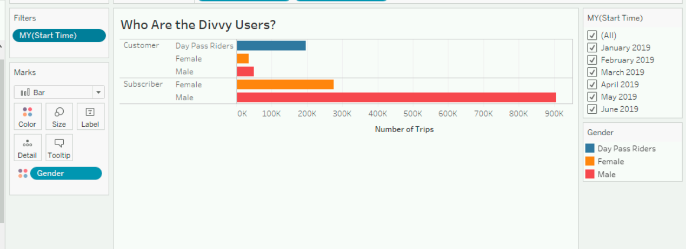
2. KPI dashboard to find divvy

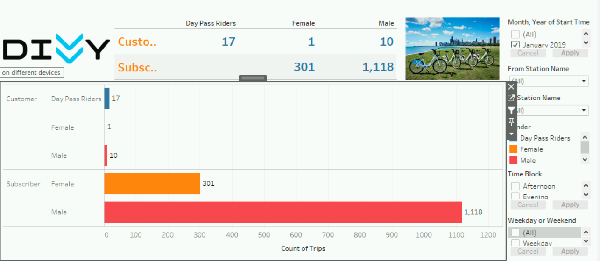

1. Understand the customers’ age distribution thru histogram can also know most are 20s – 30s range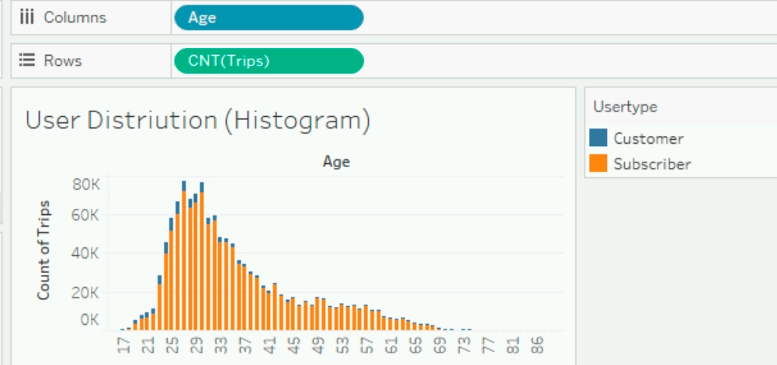
2. Create bins to see more insights, narrow bins contains noise. Below is 5 yrs bin you can see only two age groups having trips less than 250 K

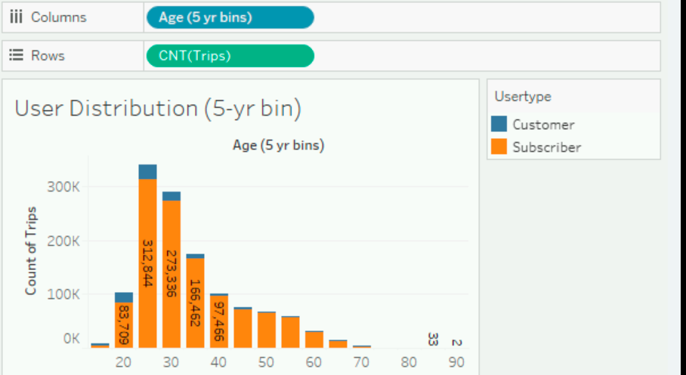

1. Create density map to see the activity increasing or decreasing close to shoreline for stations as time goes by.

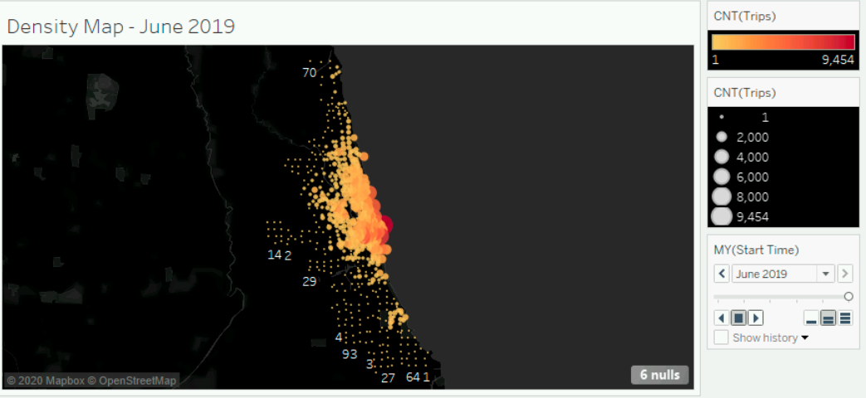

1. Using Dual axis and layering to create dimension to add docks for stations to assist decision for load balancing
2. Find least performing stations by using quick table calculation and tooltips
3. Build a map of station to provide activity by time slot and display KPI

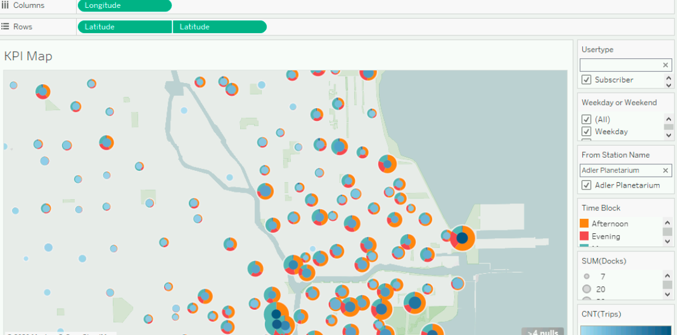

1. Create a parameter Top N Stations to dynamically view Top N Stations by trip volumes

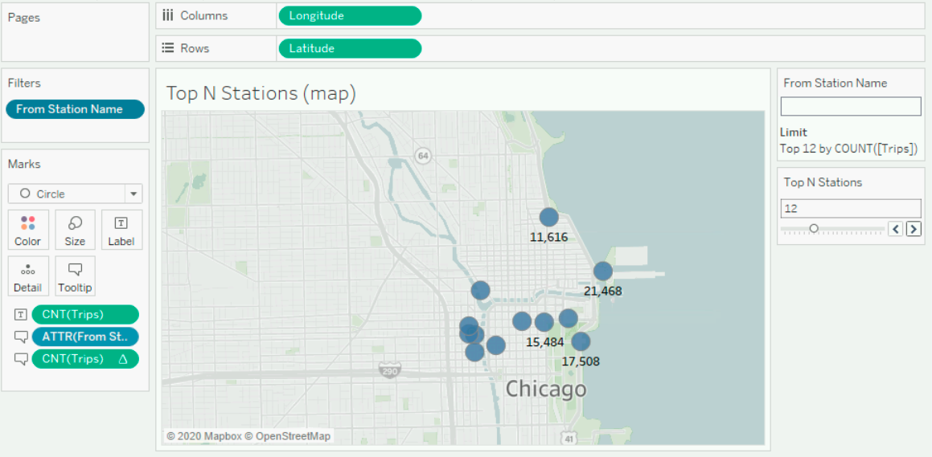

14.Create a parameter and partner with calculated field to show last true or first false for station

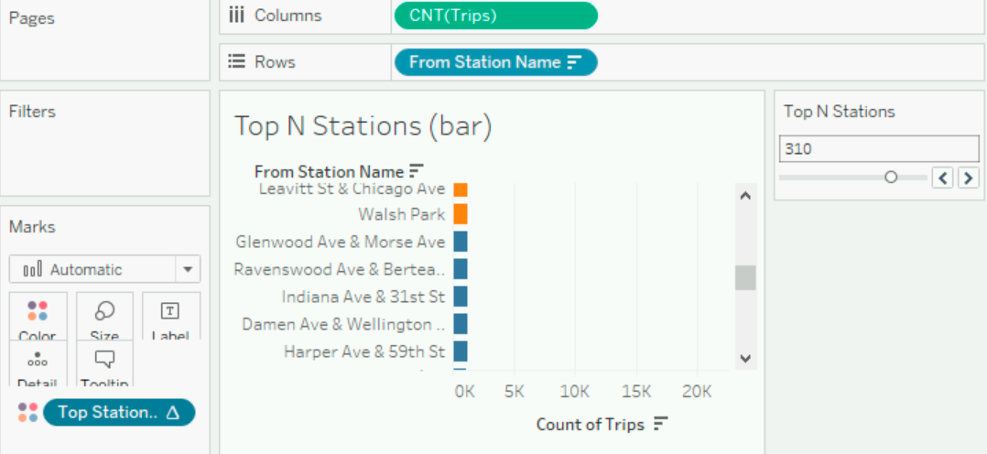

15. Use set to segment data to show % of ratio usage between windiest and not as windy

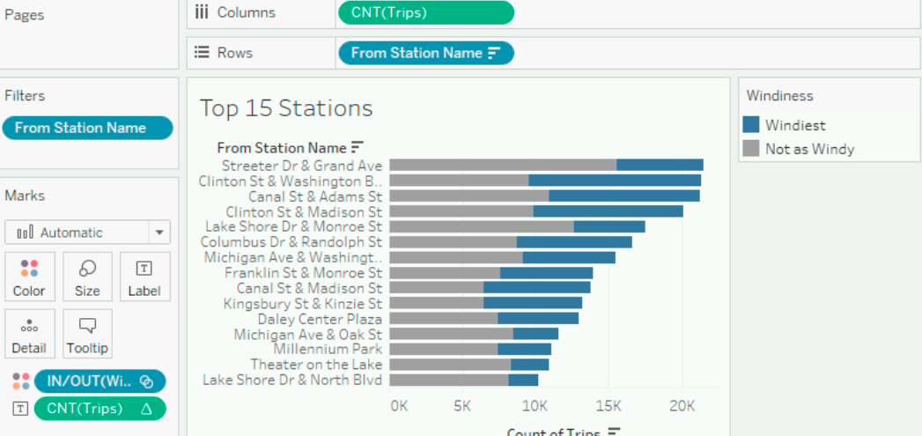

16. Combining multiple datasets to create new insights which finds the highest average wind speed also is in the month of labeled as windiest month

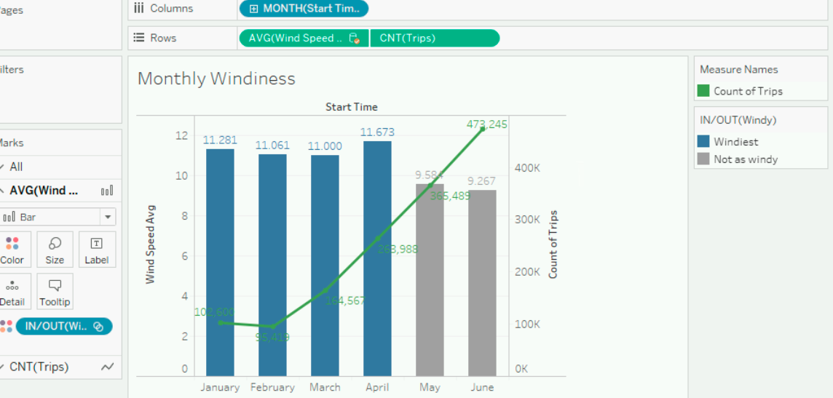17. Find how temperature affects divvy users and which week has the lowest divvy trip and the lowest temperature

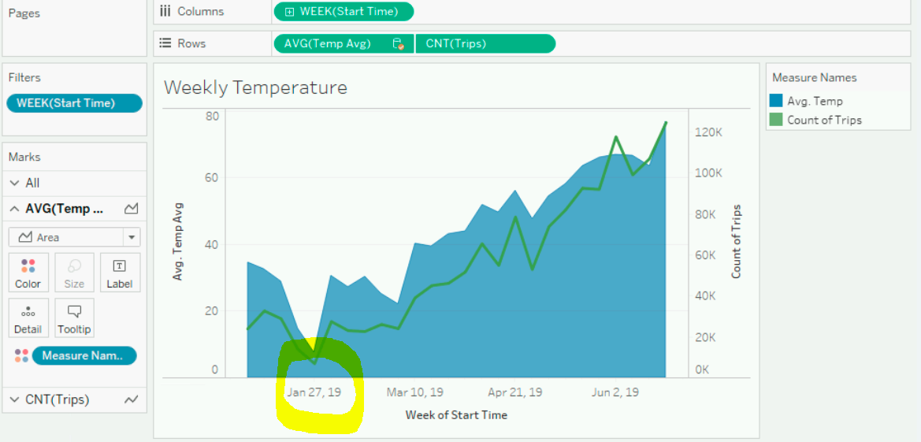

1. 10

10

1. 4.